100+ Women Who Care – Culpeper, Rappahannock, Fauquier
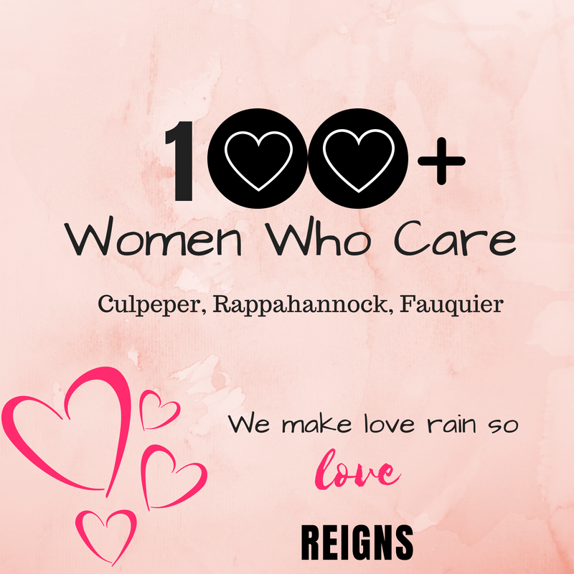
Registration & Commitment Form

Commitment: With our signature below, we are agreeing that the information we provide below is accurate and true. We are pledging to participate in 100 Women Who Care and we are making a personal commitment to contribute $200 each calendar year ($50 quarterly) to local nonprofit organizations serving the Culpeper, Rappahannock, Fauquier region. We understand that as a team, we only get one vote. We agree to donate each quarter to the nonprofit organization selected by the group’s majority vote. If we are unable to attend a quarterly meeting, we will either send our checks with another attending member to deliver on our behalf, mail it as requested after the meeting, or pay online, if that option is presented. We also acknowledge that photographs and videos taken at events and meetings may include our images and may be used in promotional materials for 100 Women Who Care- Culpeper, Rapp., Fauquier.
We understand our personal contact information is strictly confidential and we understand it will not be shared or distributed to an outside third party without our expressed consent. If 100 Women Who Care chooses to publish a Membership Directory, we agree that my contact information be included in that directory.
Yes____ No____

Partner #1 Information:
Name:
Street Address:
City, State, Zip
Phone:
Email:

Partner #2 Information:
Name:
Street Address:
City, State, Zip
Phone:
Email:

___________________________________________________________________________________________________
signature partner #1 date

_______________________________________________________________________________________________
signature partner #2 date

Completed Commitment Forms may be scanned and sent via e-mail to 100wwc.lovereigns@gmail.com or forms may be completed and turned in at a meeting. (Should you wish to discontinue membership at any time after your four-time commitment, please send an e-mail to 100wwc.lovereigns@gmail.com indicating your withdrawal.

